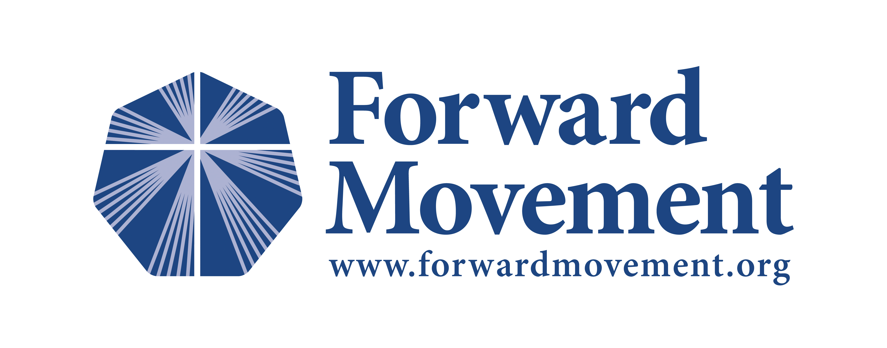

FOR IMMEDIATE RELEASE
CONTACT: Mimi Schroeder mimi@maxbookpr.com 404-447-6242

Bible Women: All Their Words and Why They Matter

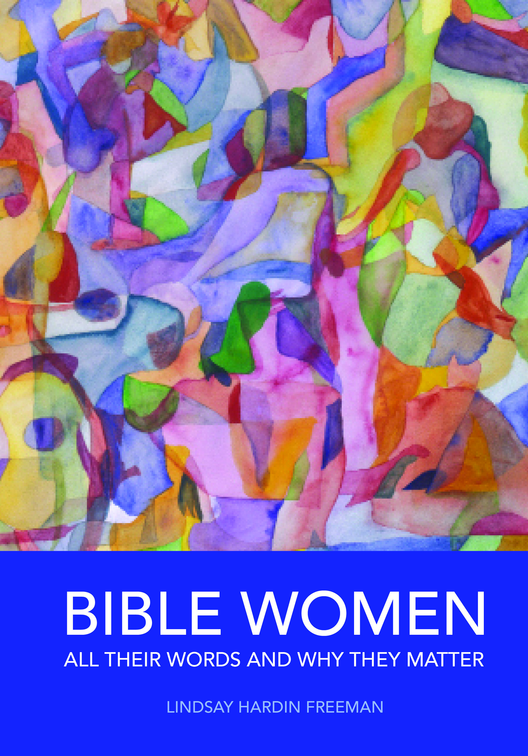
Cincinnati, Aug. 25–Women of the Bible have been trapped in dry, dusty literary caskets for centuries—but no more. Bible Women: All Their Words and Why They Matter is a groundbreaking new book by Episcopal priest and award-winning author Lindsay Hardin Freeman, who presents fascinating and unexpected insights of the ninety-three women whose words are recorded in scripture.

Freeman identifies every woman who speaks in the Bible, providing their words, context, historical background, and lessons for modern readers. Published by Forward Movement in partnership with Episcopal Church Women, the book also explores the pivotal roles of Bible women who changed the course of history, from Mary, the mother of Jesus, to Mary Magdalene, the first to see and proclaim the risen Lord.

Questions at the end of each chapter encourage individual or small-group reflection about what we might learn from each of these women and how God is speaking through them to us.

“Women in the Bible are much different from those traditionally presented in Sunday School or in light-hearted picture books,” says Freeman. “These women are tough, resilient, and brave. They take risks and speak up when no one else will. They are prophets, healers, teachers, and companions—and murderers, warriors, and spies. Their words leap off the page as interventions from God into what was otherwise a male-dominated society. They have much to say—and much to share.”

Mary, Elizabeth, and Sarah are well-known Bible women, but what about Achsah, Michal, the witch of Endor, and the wise woman of Abel? Which woman speaks the most? (Hint: it’s not Mary.) Who is the only female to talk with an animal? And what about the women who behave badly—including a woman who eats her child and a ruler who murders her grandchildren?

“In Bible Women: All Their Words and Why They Matter, Lindsay Hardin Freeman brings to light an entirely new and in-depth understanding of the often unrecognized contribution women made in the overall biblical narrative,” said the Rt. Rev. Brian N. Prior, bishop of the Episcopal Church in Minnesota.
“Freeman’s very adept biblical scholarship provides what I believe to be groundbreaking work in providing greater awareness and appreciation of the importance Bible women play in our sacred story.”

Bible Women provides information never before compiled in one place. The project began three years ago when a small group from Trinity Episcopal Church in Excelsior, Minnesota, scoured seminaries and libraries looking for a complete collection of the words of Bible women. Unable to find such a resource, the group—an Episcopal priest, a librarian, and a high school student—gathered weekly, highlighting and counting every word spoken by women in the Bible, placing each woman in her historical context, and drawing out what might be learned from their experiences.

The Episcopal Church Women, a group committed to formation and ministry among women, joined Forward Movement to support the Bible Women project. They are encouraging ECW groups around the country to use the book for Bible study and retreats.

Lindsay Hardin Freeman is an award-winning author who is passionate about sharing the stories of Bible women. Her works include The Scarlet Cord: Conversations with God’s Chosen Women and The Spy on Noah’s Ark and Other Bible Stories from the Inside Out. She was the longtime editor of Vestry Papers, a resource of the Episcopal Church Foundation.

Freeman (www.lindsayhardinfreeman.com) is now traveling the country and speaking to interested groups. To schedule a speaking engagement, contact her at lindsayhardinfreeman@gmail.com or 952-476-6267.

Bible Women is available for pre-order now and will be released on September 10, 2014

Through September 30, the book is offered at an introductory price of $17, with a discounted rate of $15 for bulk purchases of ten or more books. The cover price is $22. To order, visit www.forwardmovement.org or call 1-800-543-1813. Ebook is available on Kindle, Nook, and iBook platforms.

Forward Movement is an official, non-profit agency of The Episcopal Church located in Cincinnati, Ohio. Since 1935 their mission has been “to reinvigorate the life of the church.”

For review copies or media inquiries, contact Mimi Schroeder at 404-447-6242 or mimi@maxbookpr.com.

Step into God's sacred circle of mothers, grandmothers, warriors, prophets, prostitutes, and murderers. You won't come out the same.

# # #

